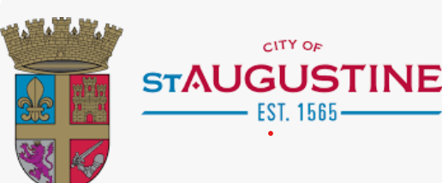

2025 Wright Family Reunion
July 17-20, 2025

DAY 1: Thursday, July 17th, 2025
​
4:00 PM Check-in Host Hotel (Hyatt Place St. Augustine/Vilano Beach)
117 Vilano Rd, St. Augustine, FL 32084
​
6:00 PM – 8:00 PM Meet & Greet
- Refreshments and hors d'oeuvres
- Distribution of Welcome bags and T-shirts
​
​
DAY 2: Friday, July 18th, 2025
​
6:30 AM - 10:00 AM Complimentary Breakfast at Host Hotel
​​
11:30 AM - 3:30 PM Beach Bash at St. Johns County Pier Park and Pavilion
350 A1A Beach Blvd, St. Augustine, FL 32080
​
4:00 PM - Free time and dinner on own
​
​
DAY 3: Saturday, July 19th, 2025
​
6:30 AM - 10:00 AM Complimentary Breakfast at Host Hotel
​
10:30 AM Free Time
​
6:30 PM - 9:30 PM Reunion Dinner & Party (White and Gold Theme)
​
​
DAY 4: Sunday, July 20th, 2025
​
6:30 AM - 10:00 AM Complimentary Breakfast at Host Hotel
​
11:00 AM Check-out/Departure
​
​

